**LIBRARY MANAGEMENT SYSTEM**

**MINI PROJECT**

**Submitted in partial fulfilment of the requirement for Degree of Bachelor of Technology in Computer Science & Engineering (AI)**

**Submitted To:**



**DR. A.P.J. ABDUL KALAM TECHNICAL UNIVERSITY, GHAZIABAD (U.P.)**

**Submitted By:**

**ANUJ KUMAR SINGH-2102901520027**

**ALOK SINGH-2102901520012**

**ANIKET-2102901520016**

**Under The Guidance Of:**

**Ms Khushboo Saxena**

**Artificial Intelligence Department**



**DEPARTMENT OF COMPUTER SCIENCE & ENGG.(AI)**

**ABESIT GHAZIABAD, UTTAR PRADESH**

**SESSION: 2022-23**

**INTRODUCTION**

The purpose of a library management system is to run the library efficiently and at low cost. A fully automated system streamlines all tasks associated with library operations. Book purchasing, cataloging, indexing, circulation tracking, and inventory management activities are taken over by the software. Such software eliminates the need for repetitive manual work and minimizes the possibility of error. library management system software helps reduce operating costs. Manually maintaining a library is labor intensive and requires an enormous amount of paperwork. Automated systems reduce the need for labor and office supplies. This translates into lower operating costs. The system saves time for both users and librarians. Users can search for books available in the library with one click. Librarians can easily answer questions about book availability. Adding, deleting, or editing databases is a simple process. Adding new members or canceling existing memberships is easy.

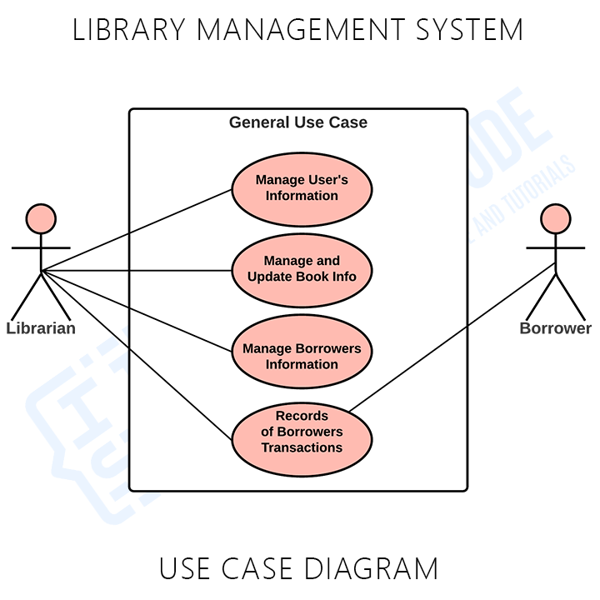

**REVIEW OF LITERATURE**

|  |  |  |  |
| --- | --- | --- | --- |
| AUTHOR | TECHNOLOGY | ADVANTAGES | DRAWBACKS |
| Aldrin Padilla Obsanga  [RibertRoque Enierga](https://www.emerald.com/insight/search?q=Ribert%20Roque%20Enierga) | 1-PHP  2-JAVASCRIPT  3-HTML | 1.Increased efficiency  2. Supervision of library activities | 1.Takes a lot of time to extract data |
| [Jibia, Mamman Salisu](https://ir.kiu.ac.ug/browse?type=author&value=Jibia%2C+Mamman+Salisu), [Mubaraka, Conrad M](https://ir.kiu.ac.ug/browse?type=author&value=Mubaraka%2C+Conrad+M), [Odie Michael](https://ir.kiu.ac.ug/browse?type=author&value=Odie%2C+Michael) | 1.PHP  2.HTML | 1.Automate its library services  2.Keep track of its clients and resources | 1.System requires post processing. |
| Shanmugam , Ramalakshmi,Sasthri,  Baalachandran | 1.SQL  2..NET | 1.Can be easily accesed by librarians  2. |  |
|  |  |  |  |

**PROBLEM STATEMENT**

In many institution of learning, library management has become a problem due to the continued use of manually supported system. Kampala International University Dar salaam Campus is among those affected by the above problem due to the increased number of students. The current system makes it hard to serve students effectively. This is seen when students queue for not less than 10 minutes to borrow a book from a librarian who has got to register each student and the book borrowed manually hence wasting a lot of time. It is this perceived inefficiency and its associated high cost of labor in hiring several library assistants that rendered this study important.

**OBJECTIVE**

The main objective was to develop an Electronic Library Management System, with a search functionality to facilitate the search and management of library resources.

#### **SPECIFIC OBJECTIVES**

1. To examine the weaknesses of a manual Library Management system.  
2. To identify requirements for Library Management System.  
3. To develop a Library Management System.

**METHODOLOGY**

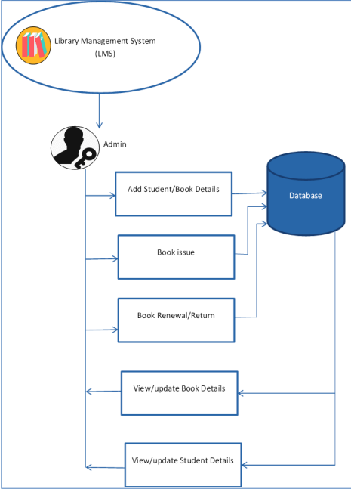

**EXPECTED OUTCOMES**

Library **Management System helps** libraries track books and their **loans, member** subscriptions and profiles. **A library** management **system** also **includes** maintaining **a** database for entering new books and **tracking** books **on loan and** their due dates.

**REFERENCES**

1. <https://www.educative.io/courses/grokking-the-object-oriented-design-interview/RMlM3NgjAyR>
2. en.wikipedia.org
3. https://www.javatpoint.com